GARY Movie Theater

RIVER LEAF MODELS, LLC

Thank you for purchasing GARY Movie Theater structure kit. Your kit includes everything you need to produce the final assembly. We recommend using “Carpenter’s Glue” available in a number of different brands, including Elmer’s. We also recommend using a steel square for aligning your walls for perpendicularity, although a drafting triangle will also suffice. A sharp X-Acto knife and a sanding tool – either fine sandpaper or a nail file will be suitable.

Step #1 –Glue the Four Wall Together.

Apply Carpenters Glue to the edges of the side walls (B & D). Again, do not use an excessive amount of glue or the glue will seep out the sides. Apply a thin bead of glue and spread it to a thin coat. You may also opt to apply a bead of glue to the inside surface of the front and side walls (A & C).
Carpenters Glue will afford you the time to perfectly align your walls, as there is some “setup” time. I recommend you do one corner at a time in one sitting. This will give you the flexibility to adjust the perpendicularity of the structure. Once you have your walls all secured, I recommend letting the glue dry for 24 hours. While the glue is setting, you can use the roof panel as a checking tool to ensure the building corners are perpendicular. You may want to use clamps positioned with the clamping faces on the front and rear of the building to form a tight glued seal.

On structures made of lighter or less sturdy material, it is common practice to run a square brace tucked into each quarter using 1/4” or 3/8” square wood. On River Leaf Models, this is not necessary; however, the option is there to do so if you wish.

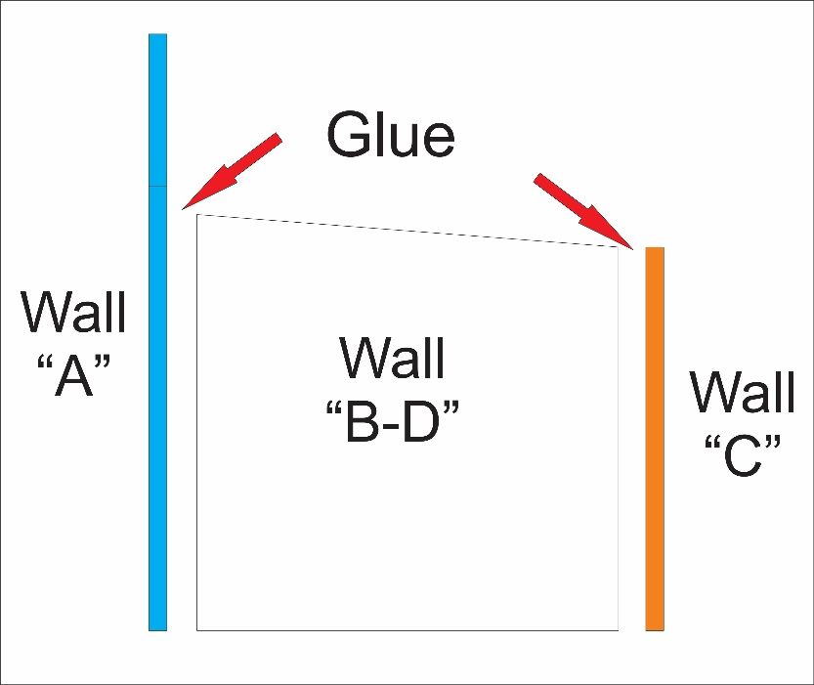

FIGURE 1 – GLUING YOUR STRUCTURE WALLS

Step #2 - Painting the Base Structure.

There are a number of methods for painting the structure and experienced modelers will find the structure is well suited to any number of painting and detailing techniques. Here is a technique I believe will deliver excellent results.
Use Gray Chalk paint. Dry very flat with a real concrete appearance.

Step #3 – Assembling the Marquee.

Your structure is now stable, squared up and ready for the details. Prior to any installation, this is the time to decide on your color scheme and paint your detail parts, including window and door frames. From my experience, painting these prior to installation will yield the best result.

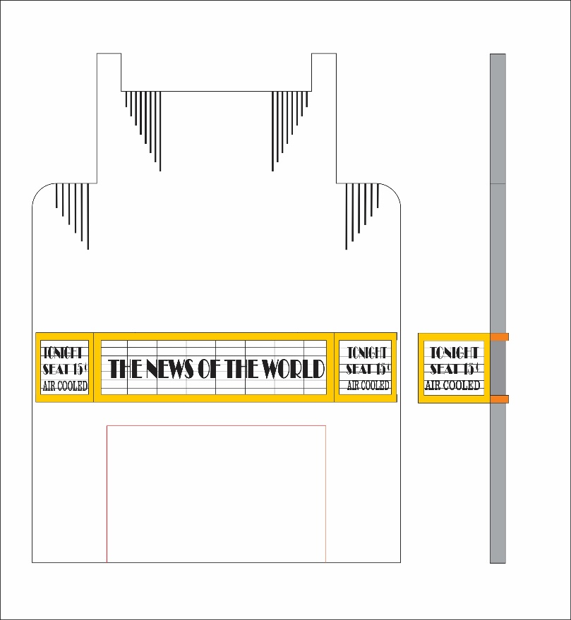

FIGURE 3 – ASSEMBLING THE MARQUEE.

The Marquee is composed of different parts, get familiar before any gluing.
Paint the acrylic sign using black paint, let it dry and wipe of the leftover, leaving the etched, black.

Use the building as a jig to assemble the marquee inserting both overhang pieces. The bottom one was drilled to allow the light illuminate the entrance. Then install the acrylic sign between the overhang. Using CA glue, you can achieve better result. The side sign is not the same there is a left and right. How recognize them, the fonts is not centered, the left one has the font all the way to the left and the right the fonts are all the way to the right.
Glue the frames over the marquee using carpenter glue or CA and repaint the seams if is necessary.

After everything is well glued and dry remove the marquee, add some light and reassemble. Is not necessary to glue it because might you need to service the internal light installed.

Step #4 – Assembling the Front Cornice.

The front top cornice is composed by parts that need to be painted separately.
After you finish the top front cornice paint, glue it on the front wall, centering it in the middle of the building and resting over the overhang.

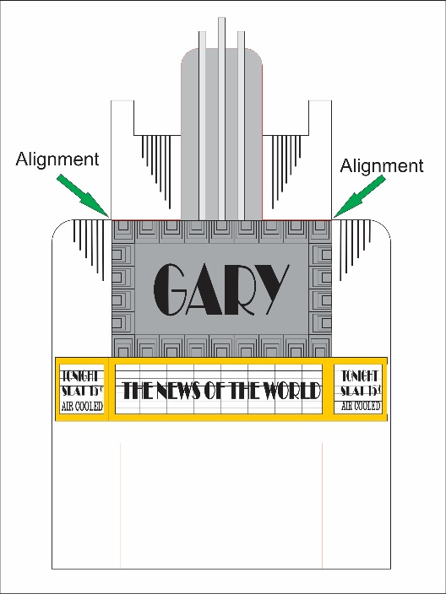
Insert and glue the three ornaments for the cornice. The large one will be installed in the middle, and the other two in each side.

Paint and install the leaf ornaments gluing one over the other keeping the length order.
The wider ones will be installed on the front and the narrow on the external side.
(Figure #4.)

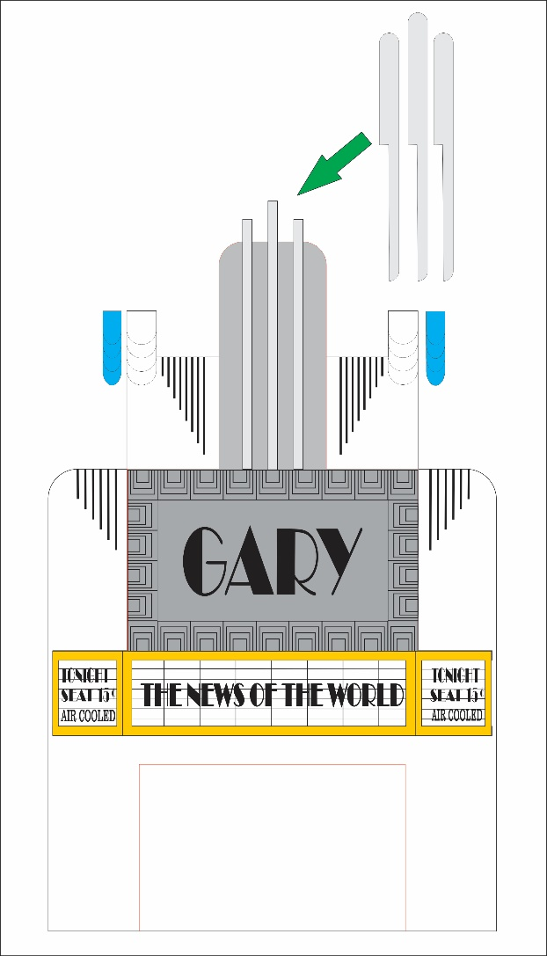

FIGURE #4 – ASSEMBLING THE FRONT CORNICE

.
Step #5 – Assembly the Front Entrance

The front entrance includes the ticket booth.
Paint all the part previous the assembly.
Add small amount of glue and glue the ticket window frame, then install the window. The window was etched, paint it prior installation.

The doors are precut in case you want them open. Glue the acetate from the inner side and glue them from inside the front entrance. Add the handrail to each door.

Glue the front entrance from inside the building flushing it with the building bottom part, and aligning it centered.
Install the showcase frame on each entrance side. Movie pictures are available on our website under “resources- signage”

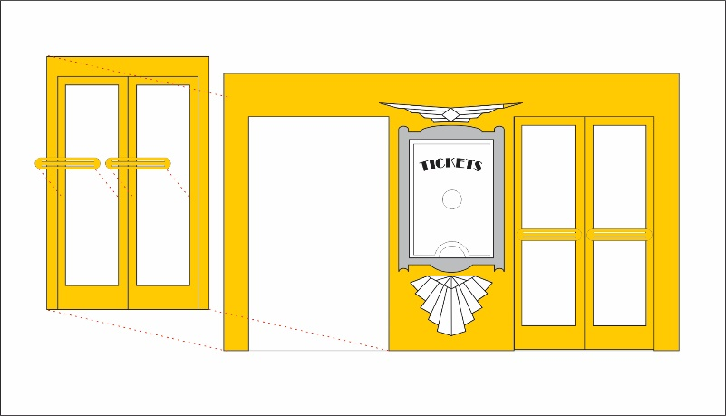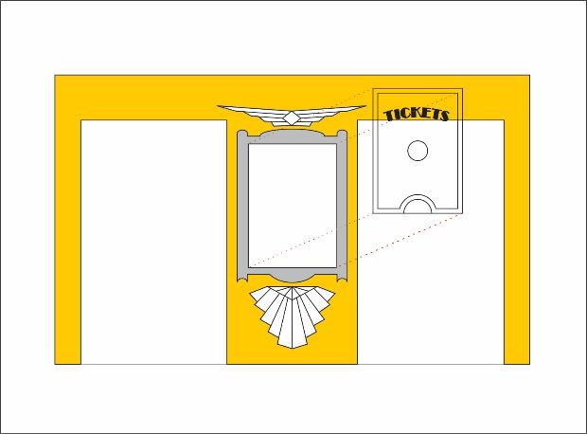

FIGURE #5 – FRONT ENTRANCE, DOORS and DETAILS.

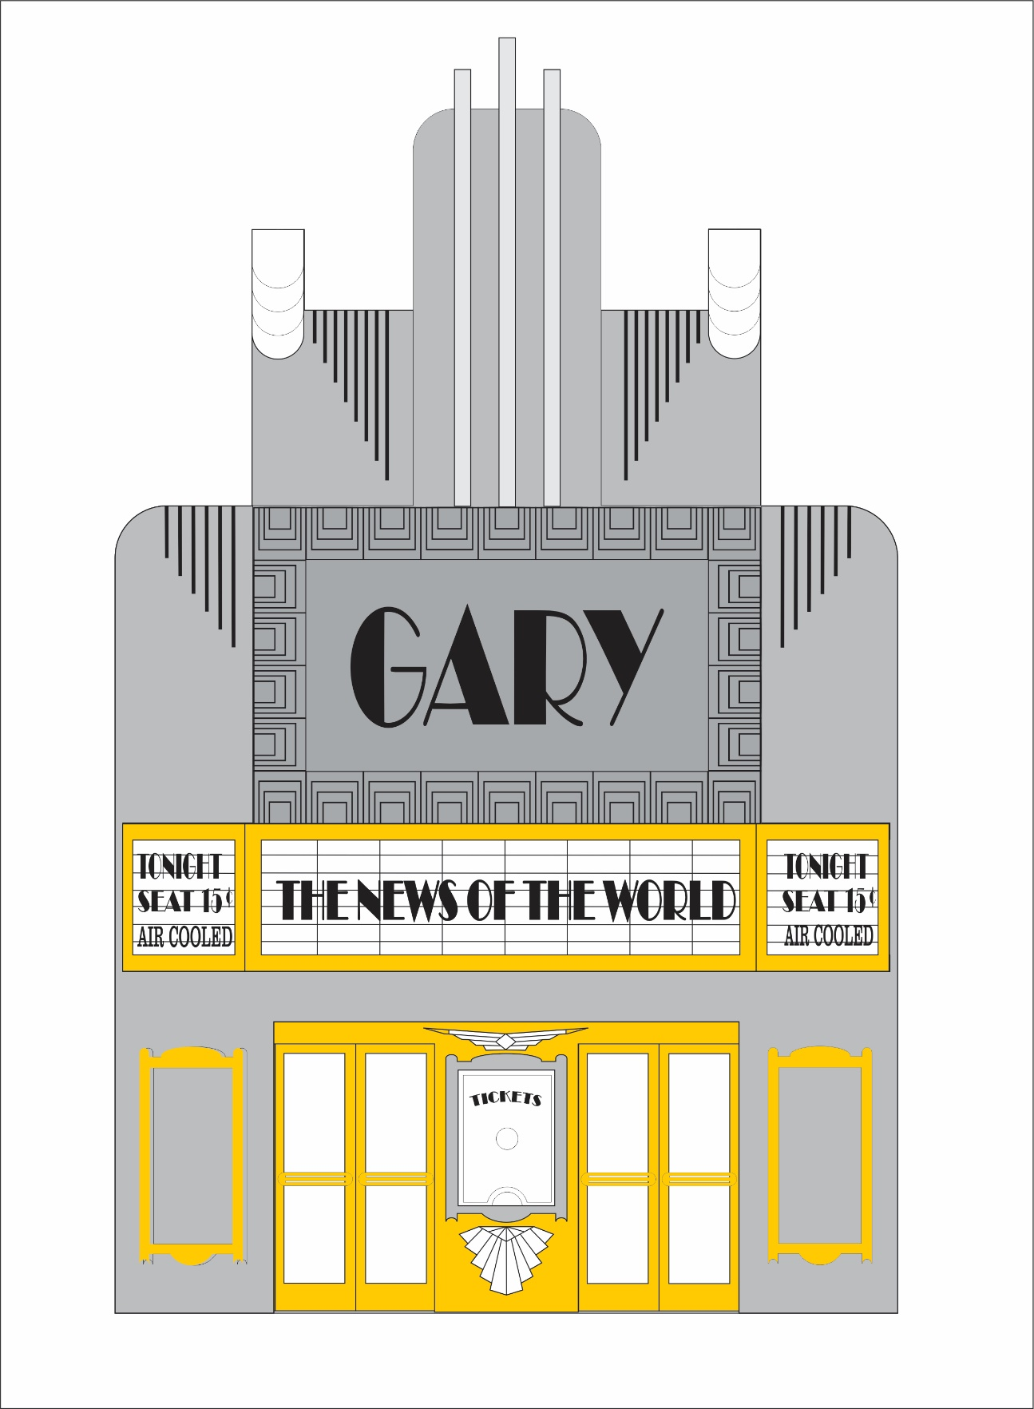

FIGURE #5.1 – FRONT ENTRANCE, DOORS and DETAILS.

Step #7 - Roof
Roof installation is self explanatory. I recommend painting the roof black and apply masking tape overlapping the edge for real appearance.

Congratulations! Your building is complete!
With your building now finished, you may opt to further enhance the structure using weathering techniques such as chalk or misting. Keep in mind weather runs from top to bottom and will be concentrated in areas where water may gather and run off, like around windows. Likewise, you may have weather “splash up” along the base. We will be posting tips on aging and weathering on our website in the near future.

If you have questions on construction or suggestions, please contact us by email at
riverleafmodels@gmail.com

Andre Garcia
www.riverleafmodesl.us

