The Elbow Room

RIVER LEAF MODELS, LLC

Thank you for purchasing The Elbow Room structure kit. Your kit includes everything you need to produce the final assembly. We recommend using “Carpenter’s Glue” available in a number of different brands, including Elmer’s. We also recommend using a steel square for aligning your walls for perpendicularity, although a drafting triangle will also suffice. A sharp X-Acto knife and a sanding tool – either fine sandpaper or a nail file will be suitable.

Step #1 –Glue the Four Wall Together.

Apply Carpenters Glue to the edges of the side walls (B & D). Again, do not use an excessive amount of glue or the glue will seep out the sides. Apply a thin bead of glue and spread it to a thin coat. You may also opt to apply a bead of glue to the inside surface of the front and side walls (A & C).

Carpenters Glue will afford you the time to perfectly align your walls, as there is some “setup” time. I recommend you do one corner at a time in one sitting. This will give you the flexibility to adjust the perpendicularity of the structure. Once you have your walls all secured, I recommend letting the glue dry for 24 hours. While the glue is setting, you can use the roof panel as a checking tool to ensure the building corners are perpendicular. You may want to use clamps positioned with the clamping faces on the front and rear of the building to form a tight glued seal.

On structures made of lighter or less sturdy material, it is common practice to run a square brace tucked into each quarter using 1/4” or 3/8” square wood. On River Leaf Models, this is not necessary; however, the option is there to do so if you wish.

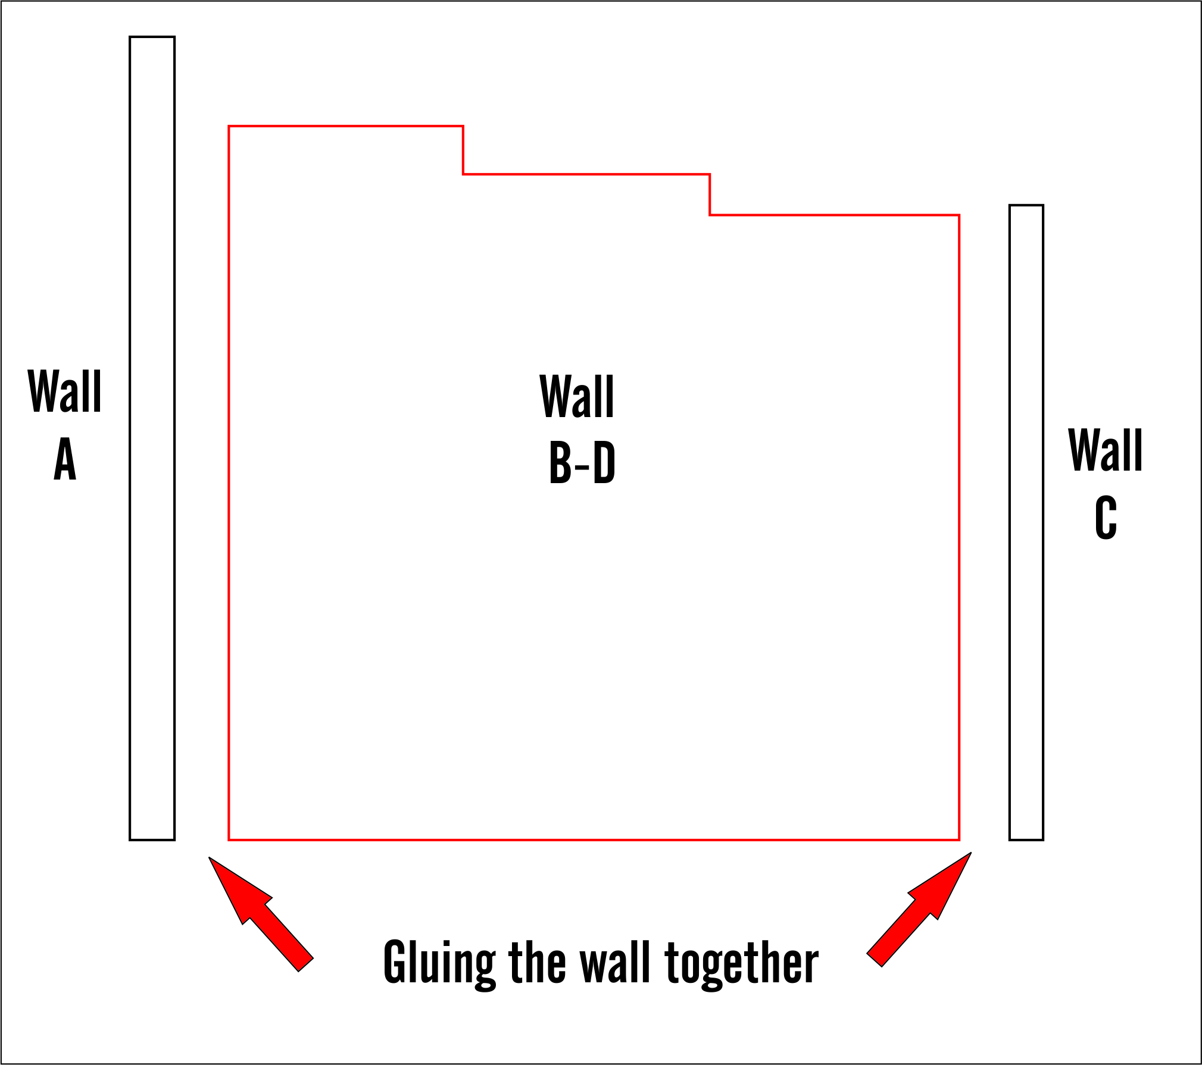

FIGURE 1 – GLUING YOUR STRUCTURE WALLS

Step #2 –Glue the strip of brick facing to the side of the front wall.

The walls of your kit are cut from MDF with the brick pattern etched to the front surface. As a result, the side of the wall section of the rear of the building (C) require adding the brick pattern. As show in the Figure 2, apply the supplied brick pattern strip to the sides of the rear wall using carpenter glue.

Be careful to not use excessive amount of glue when applying the strip. Glue will seep from the side. Apply a thin bead down the center of the side surface of the front wall and spread it evenly over the area. Apply the brick pattern strip on the glued area.

Notice the left side is shorter than the right side to match the brick pattern engraved on the side walls.

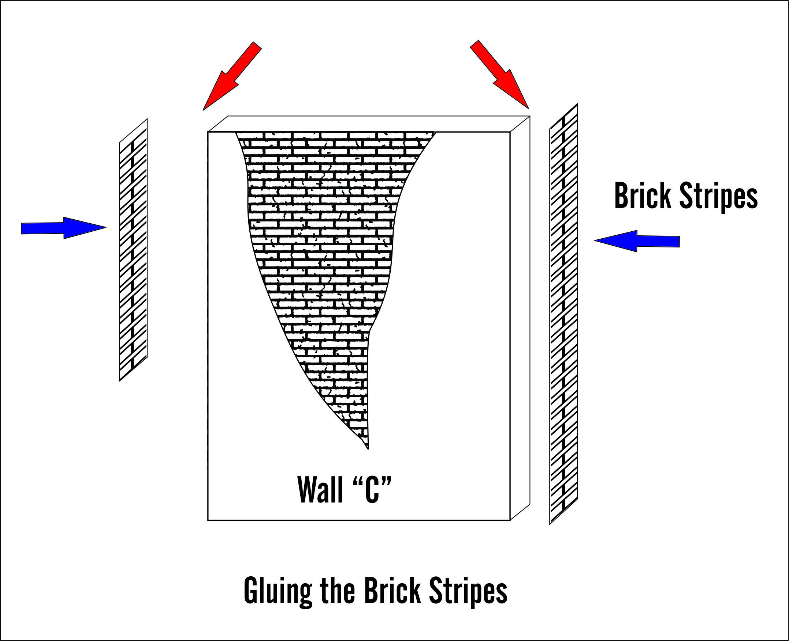
FIGURE 2 – APPLYING BRICK PATTERN STRIP

Step #3 - Painting the Base Structure.

There are a number of methods for painting the structure and experienced modelers will find the structure is well suited to any number of painting and detailing techniques. Here is a technique I believe will deliver excellent results.

Once the glue has completely dried, you will find you have a very sturdy base on which to work. To achieve the effect of mortar lines between brick layers, paint the entire structure with an undercoat of the color you want for your mortar lines. White is a logical choice as it gives you distinctive mortar lines and provides a consistent undercoat base for the brick surface of the building. Paint the entire structure, concentrating on the engraved mortar lines and let the building thoroughly dry.

Having the building completely dry is an important step, as your second step is to paint the brick surface and you want to avoid streaking. After the building is completely dry, paint your desired color on the brick surface. You want to avoid getting paint in the mortar lines. Use acrylic paint in your desired color using a “dry brush” technique. Dry brushing calls for using a minimal amount of paint on your brush and painting the surface lightly – preferably with a broader brush. This technique will have the paint cover the brick surface without seeping into your mortar lines.

In order to achieve a “dry brush” after dipping your brush into paint, whip a few strokes on your backdrop paper or other surface. This will remove the excess paint from the brush. Dry brushing may require you to apply a few coats. Don’t try to achieve full coverage in one coat. Dry brushing is a process in which you build your color through a series of layers. By following these instructions, your finished product will have a distinctive mortar line and a pleasing brick surface color. Once your structure is painted and completely dry, you can move on to adding the details.

The building is cut in a manner to simulate a base brick with stucco over the top of the brick and chipping off in areas. The sample photos on our website show this as red brick with grey stucco. Use your imagination to create your own combinations. You may opt to duplicate this sample, or go with a completely painted over look. There is no right or wrong.

Step #4 – Applying Doors and Details
After painting the structure, go ahead and select your colors for the detail parts which include the steps, door, overhang sign and electrical meter.
The electrical meter is made from 3 pieces the body, the dial and conduit. Place the dial piece over the painted body and place it on the building, preferable install it to the eye level, then place the conduit.
The Overhang is made from laserboard. This is strong material but the shape makes it little fragile. Download the sign available in our website, resource section. Cut both and glue it on each side. White or carpenter glue will work fine. Apply the whole sign perpendicular to the building centered with the main door.

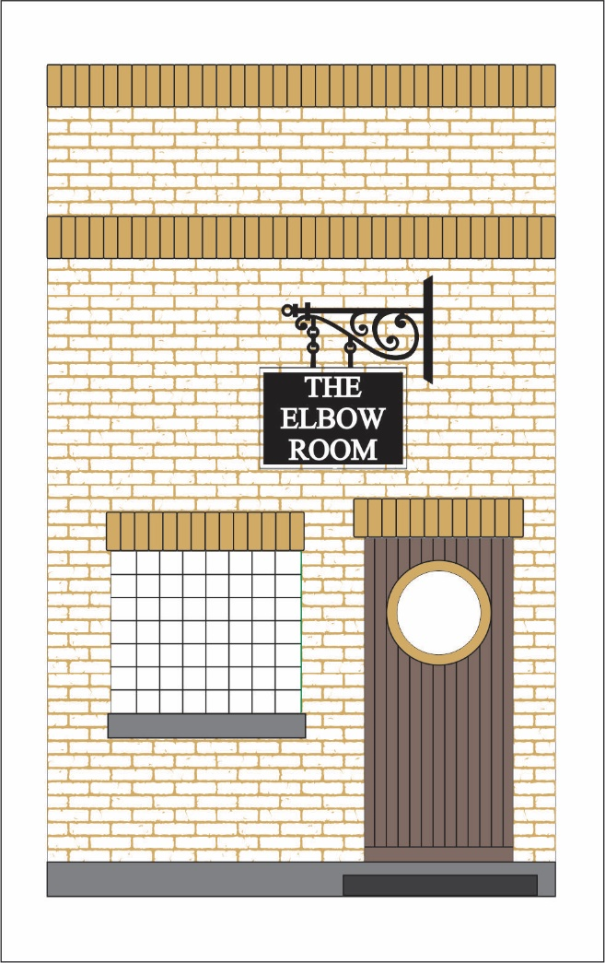
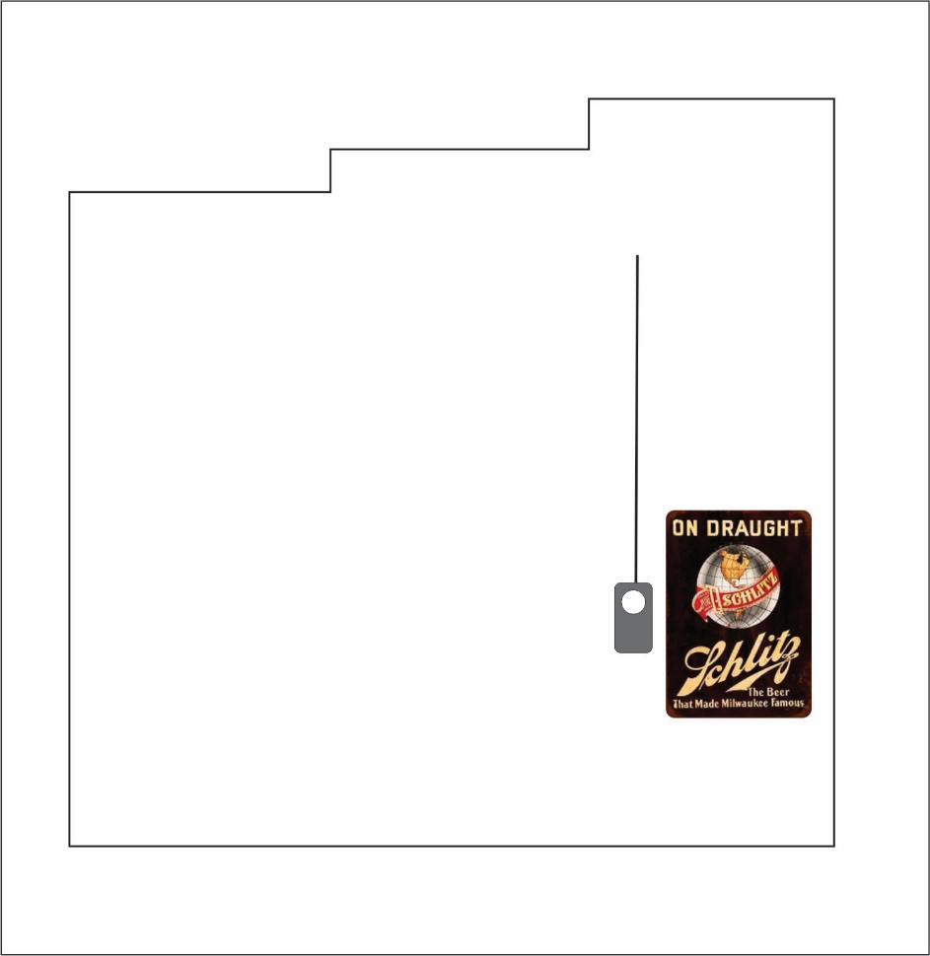
FIGURE #3 –DOOR & DETAIL PLACEMENT

Step #7 - Roof
Roof installation is self explanatory. I recommend painting the roof black and apply masking tape overlapping the edge for real appearance. The roof is a snug fit in place; however, you can glue strips of wood to the inside of the walls to serve as additional support.

Congratulations! Your building is complete!
With your building now finished, you may opt to further enhance the structure using weathering techniques such as chalk or misting. Keep in mind weather runs from top to bottom and will be concentrated in areas where water may gather and run off. Likewise, you may have weather “splash up” along the base. We will be posting tips on aging and weathering on our website in the near future.

If you have questions on construction or suggestions, please contact us by email at
riverleafmodels@gmail.com

Andre Garcia
www.riverleafmodesl.us

